Database Management Systems Lab Work

1.Create a table Emp with attributes Ename, Ecity, Salary, Enumber with following constraints: Enumber is the primary key and should start with ‘E’, Ecity should have default values as Delhi.

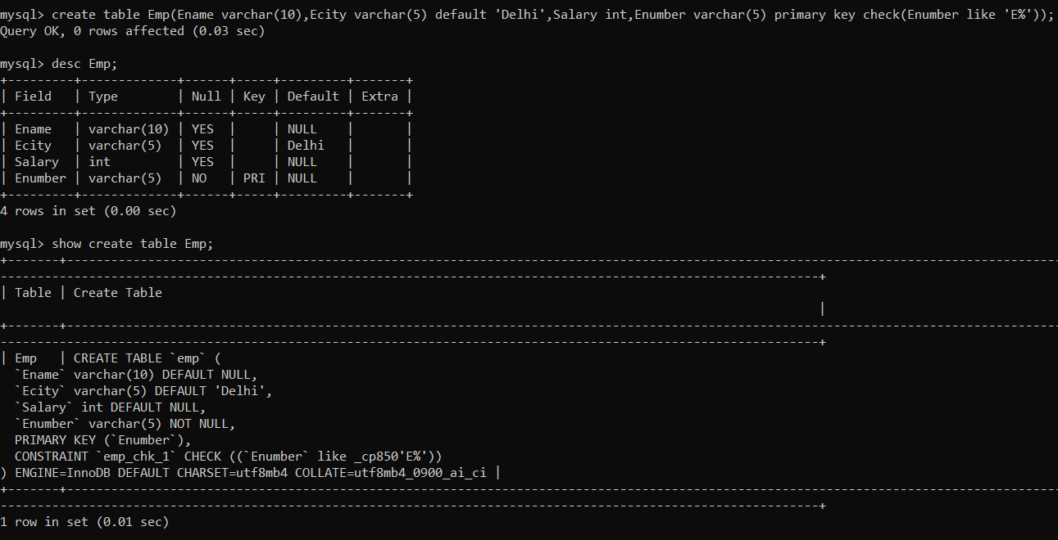

2. Create another Table Department with attributes Did, Budget and Manager_id, Dname with following constraints: Budget should not be less than 10000.

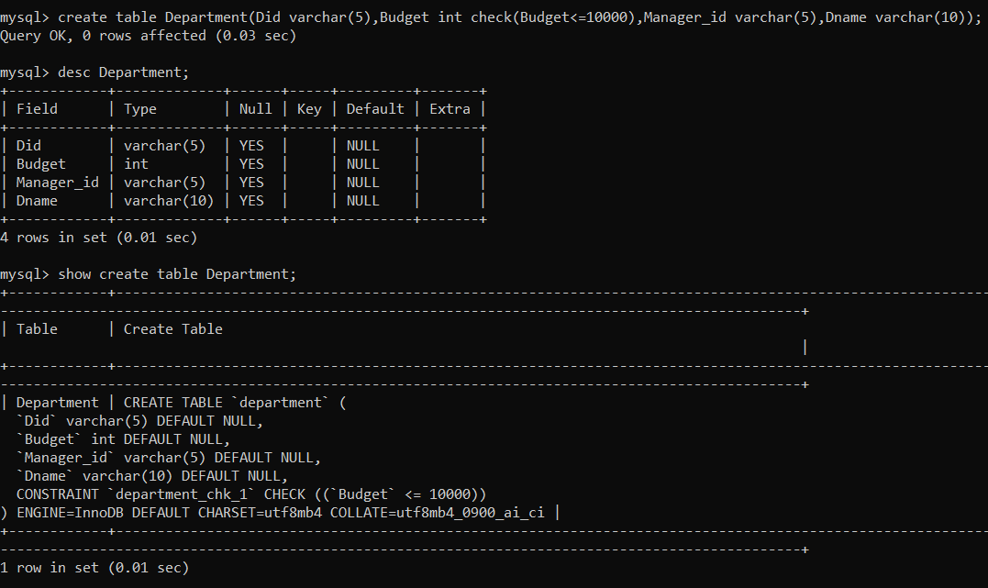

3. Create another Table Works with attributes Did and Eid & combination of both as primary key.

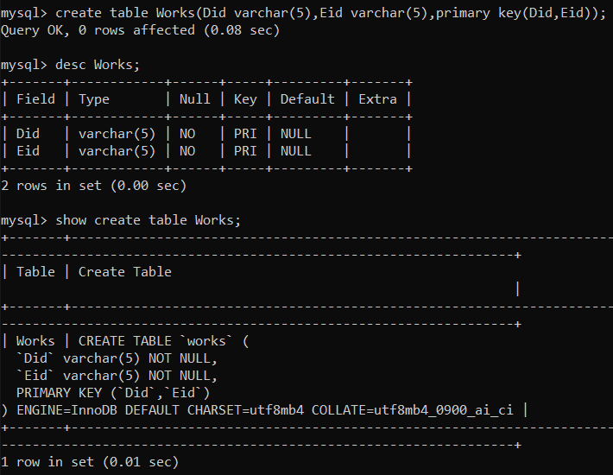

4. Alter table Department and make Did as the primary key.

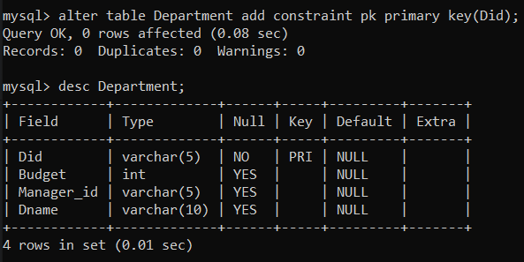

5. Alter table Department and make Manager_id as the foreign key.

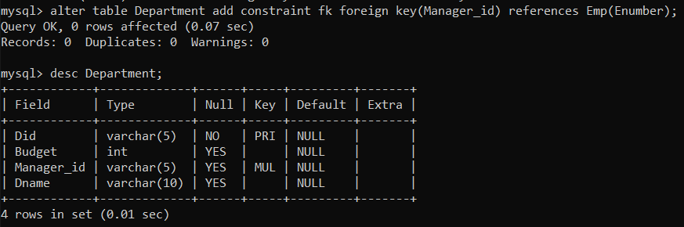

6. Alter table Works and make did and eid as foreign key.

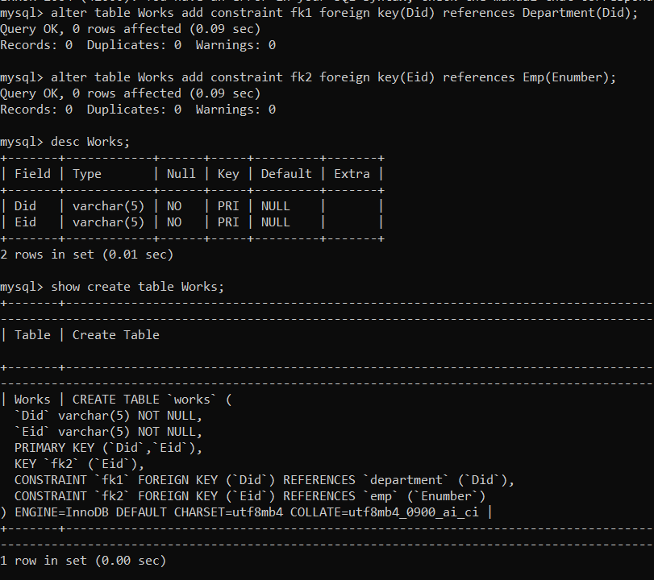

7. Create table book with attributes ISBN, Title, Price, Pid with following constraints: ISBN is the primary key, Price should be >=20/<=200, Title should not have null values.

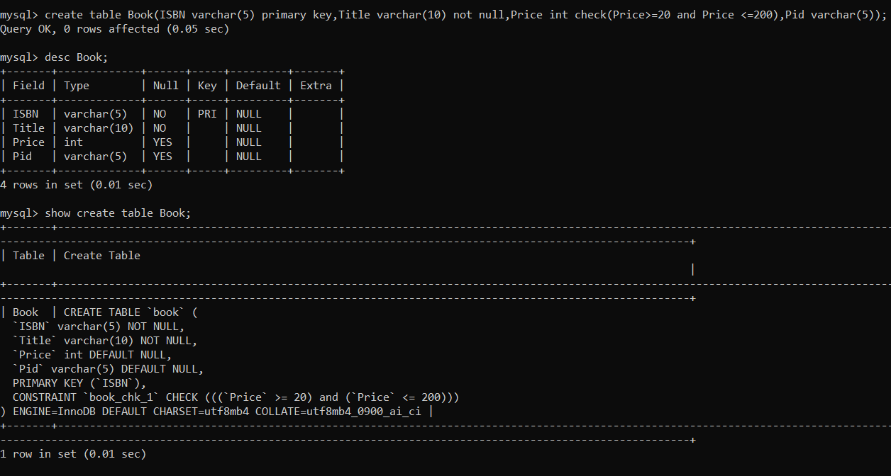

8. Create table publisher with attributes Pid, Pname, State with following constraints: Pname should not have null values; State should be either Haryana, Tamil Nadu, Maharashtra.

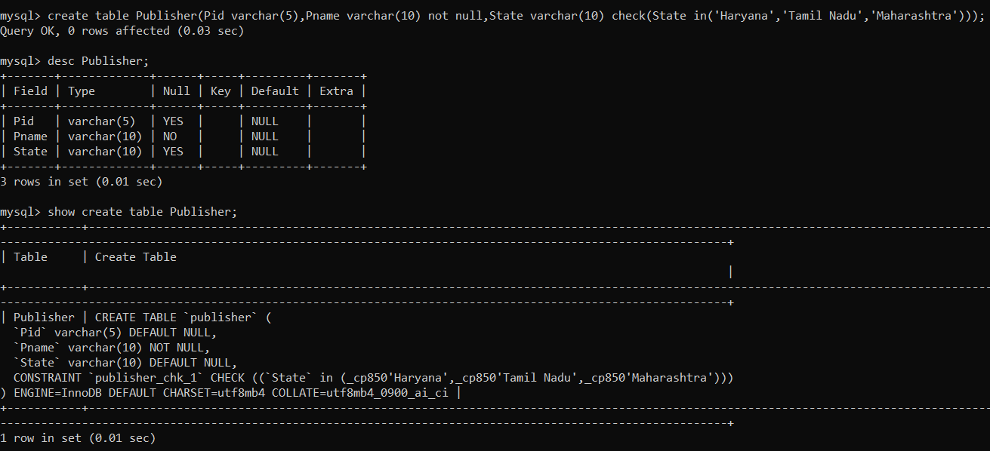

9. Alter the table publisher by making Pid as primary key.

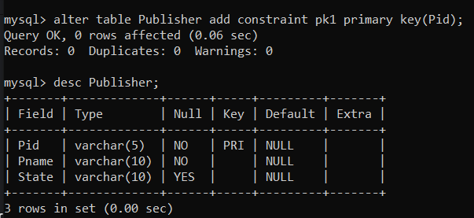

10. Alter the table book by making Pid as foreign key.

